System flow:
- User Traffic → ELB → CloudWatch → Lambda → SNS → Email
- ELB generates 5xx errors
- CloudWatch stores metrics
- Lambda checks metrics every 5 mins
- If errors > threshold → sends alert via SNS
Step: Launched EC2 Instance and Connected to EC2 and ran below commands
sudo yum update -y
sudo yum install httpd -y
sudo systemctl start httpd
sudo systemctl enable httpd
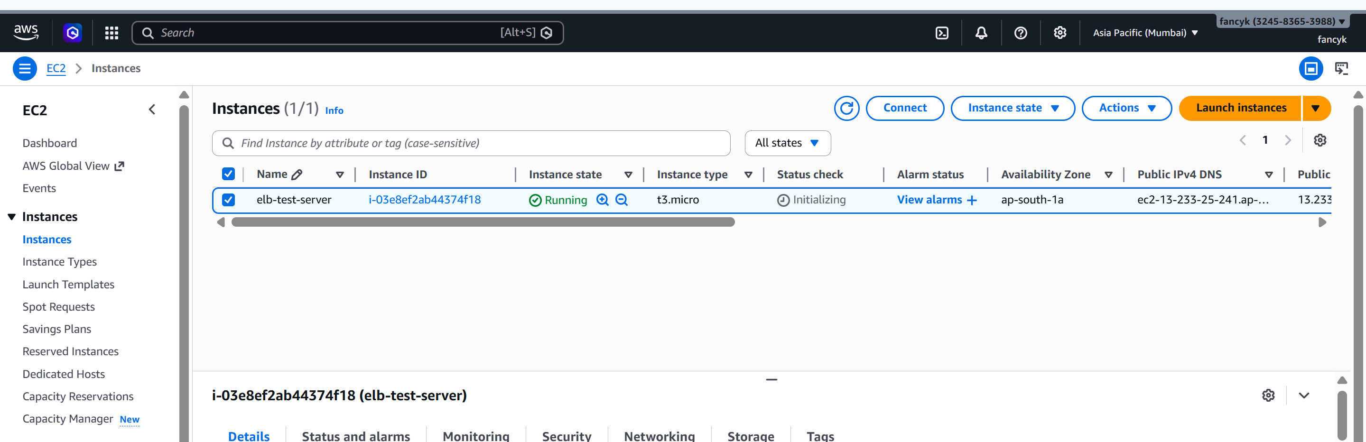
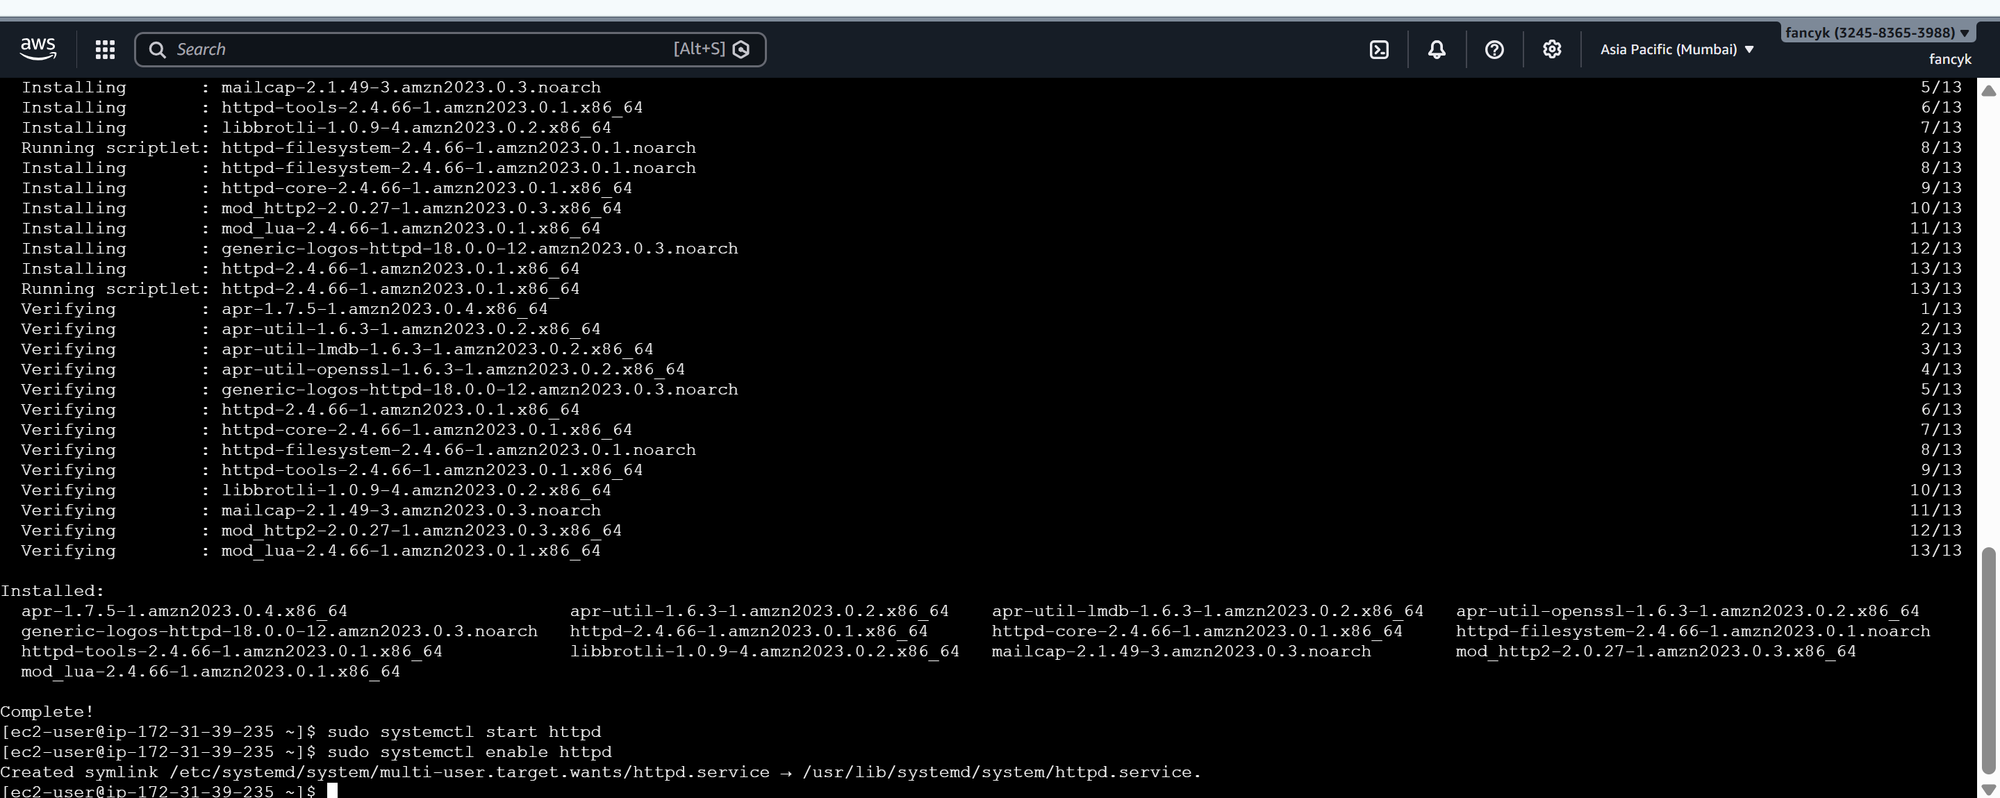
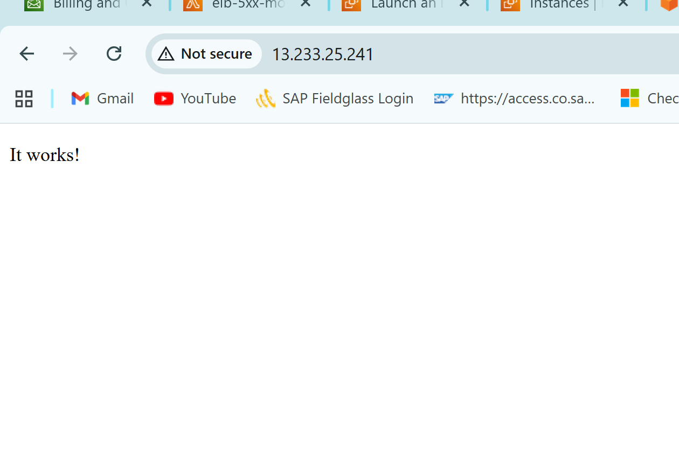
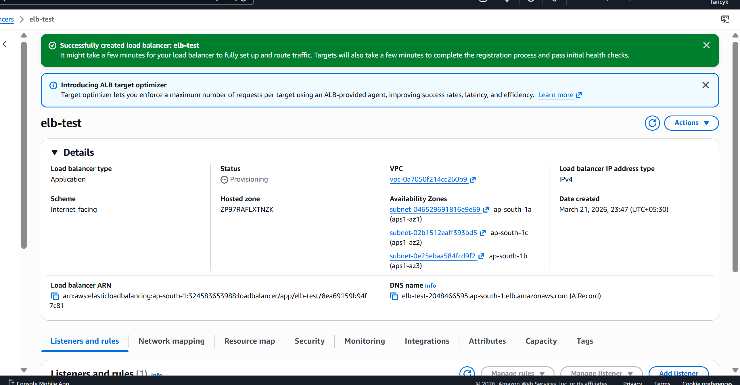
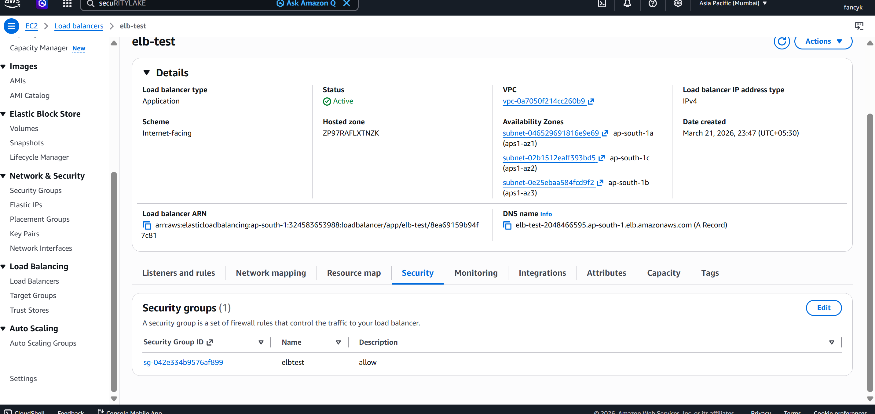
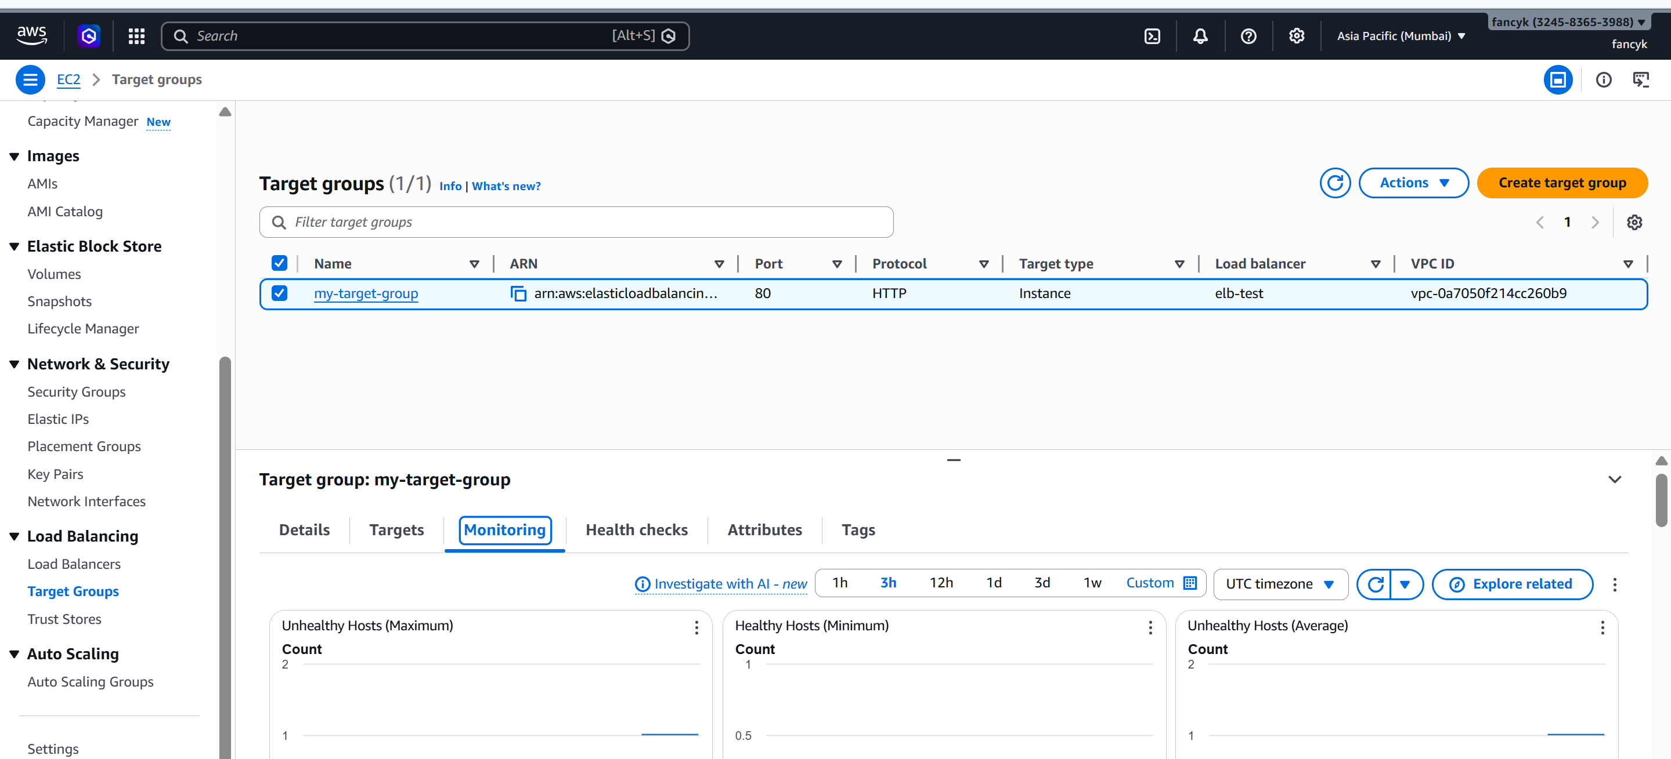

Step 1: Created SNS Topic (Notification System)
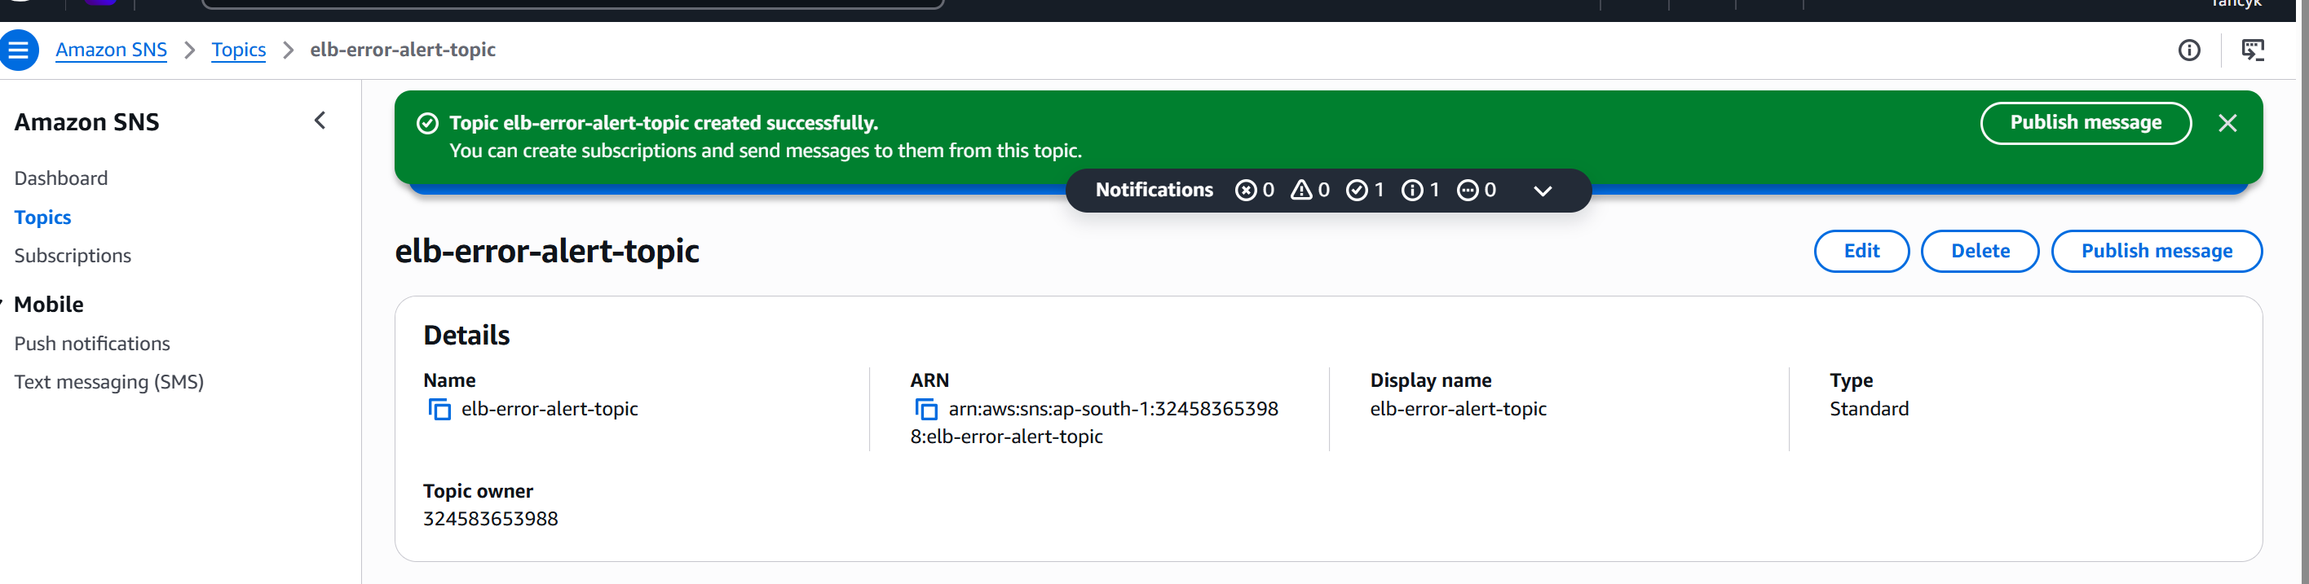
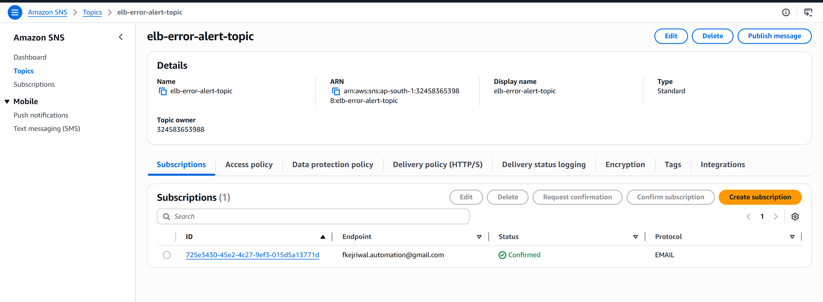
Step 2: Created IAM Role for Lambda
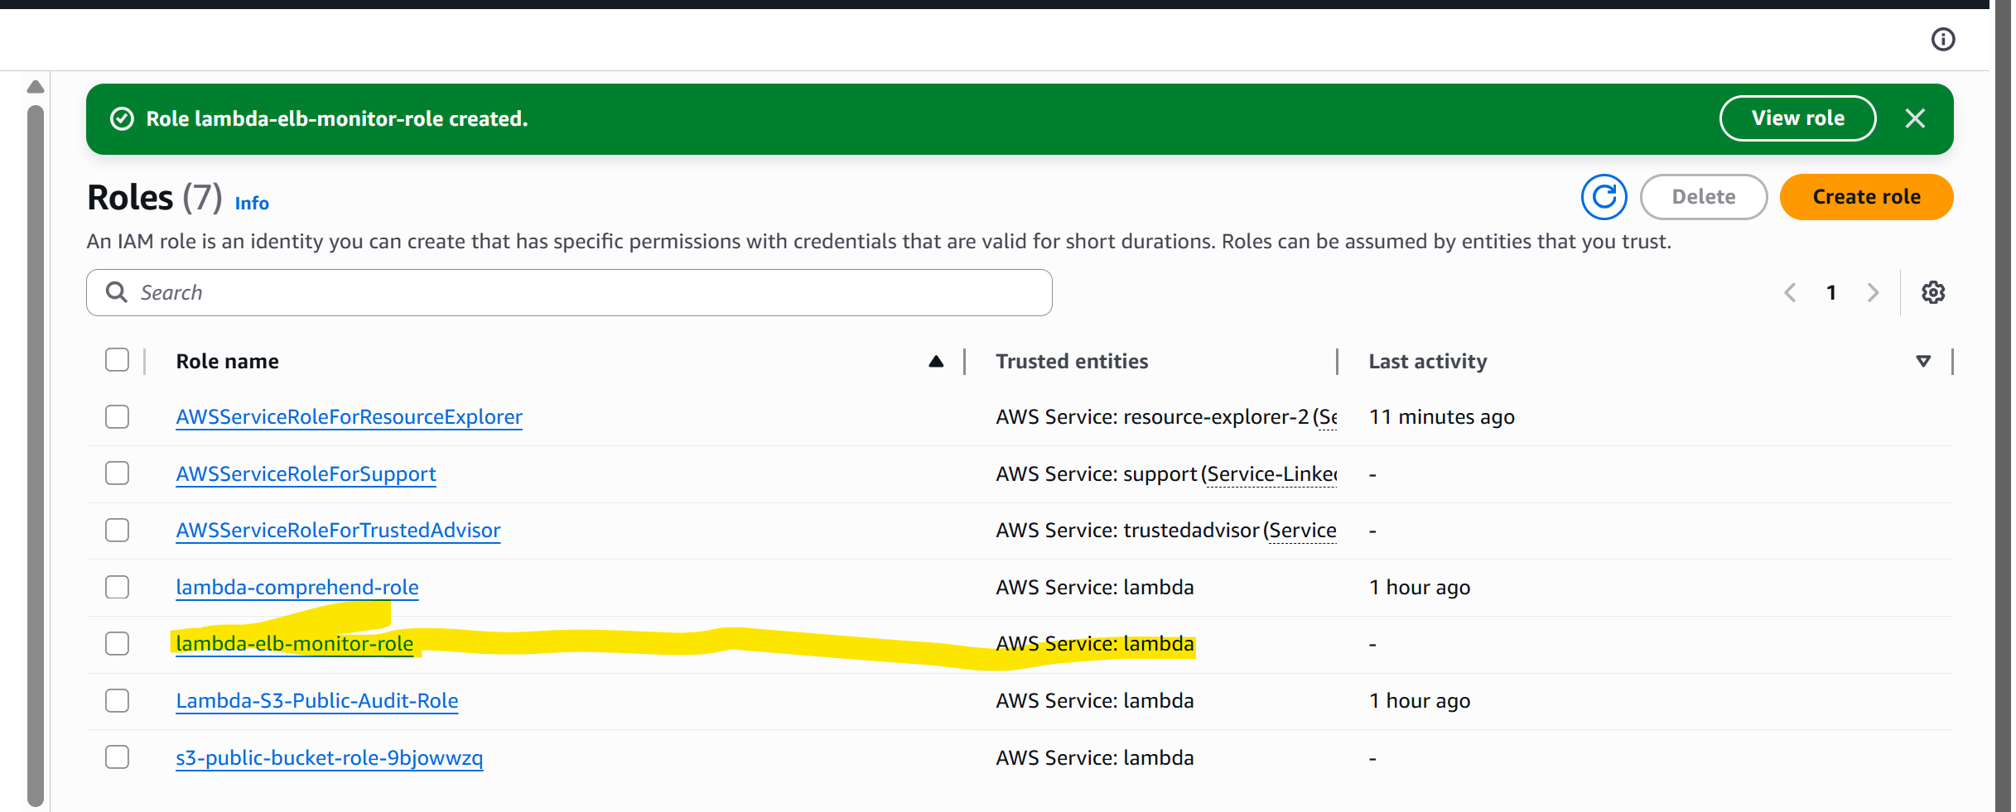
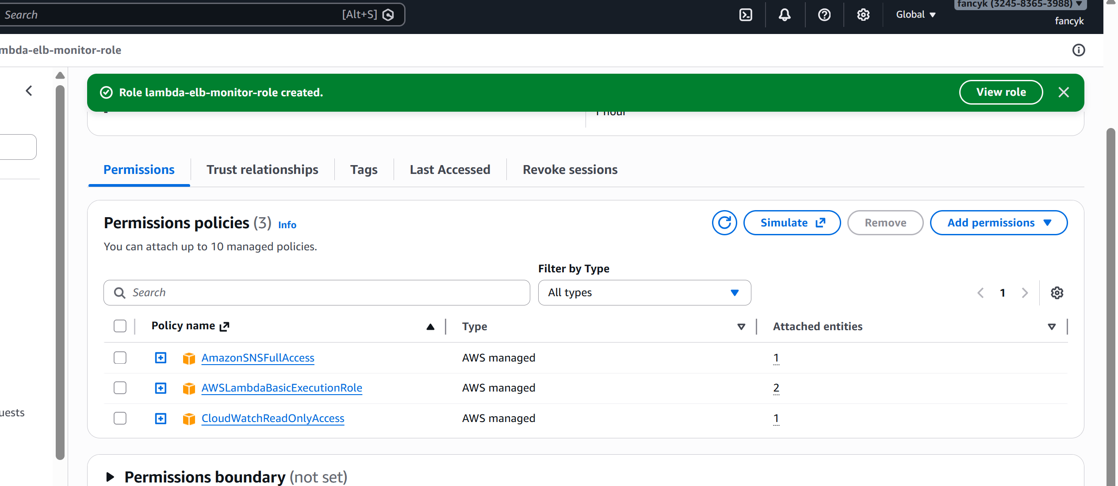

Step 3: Created Lambda Function
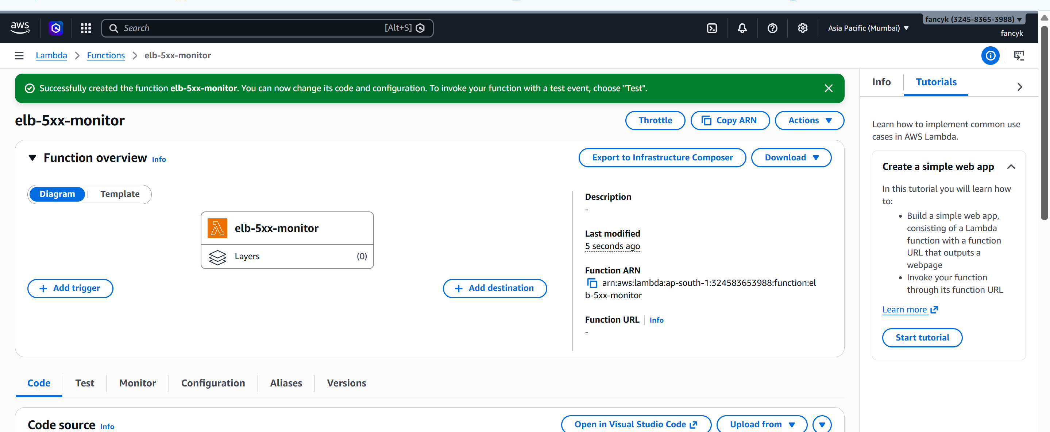
Deployed code
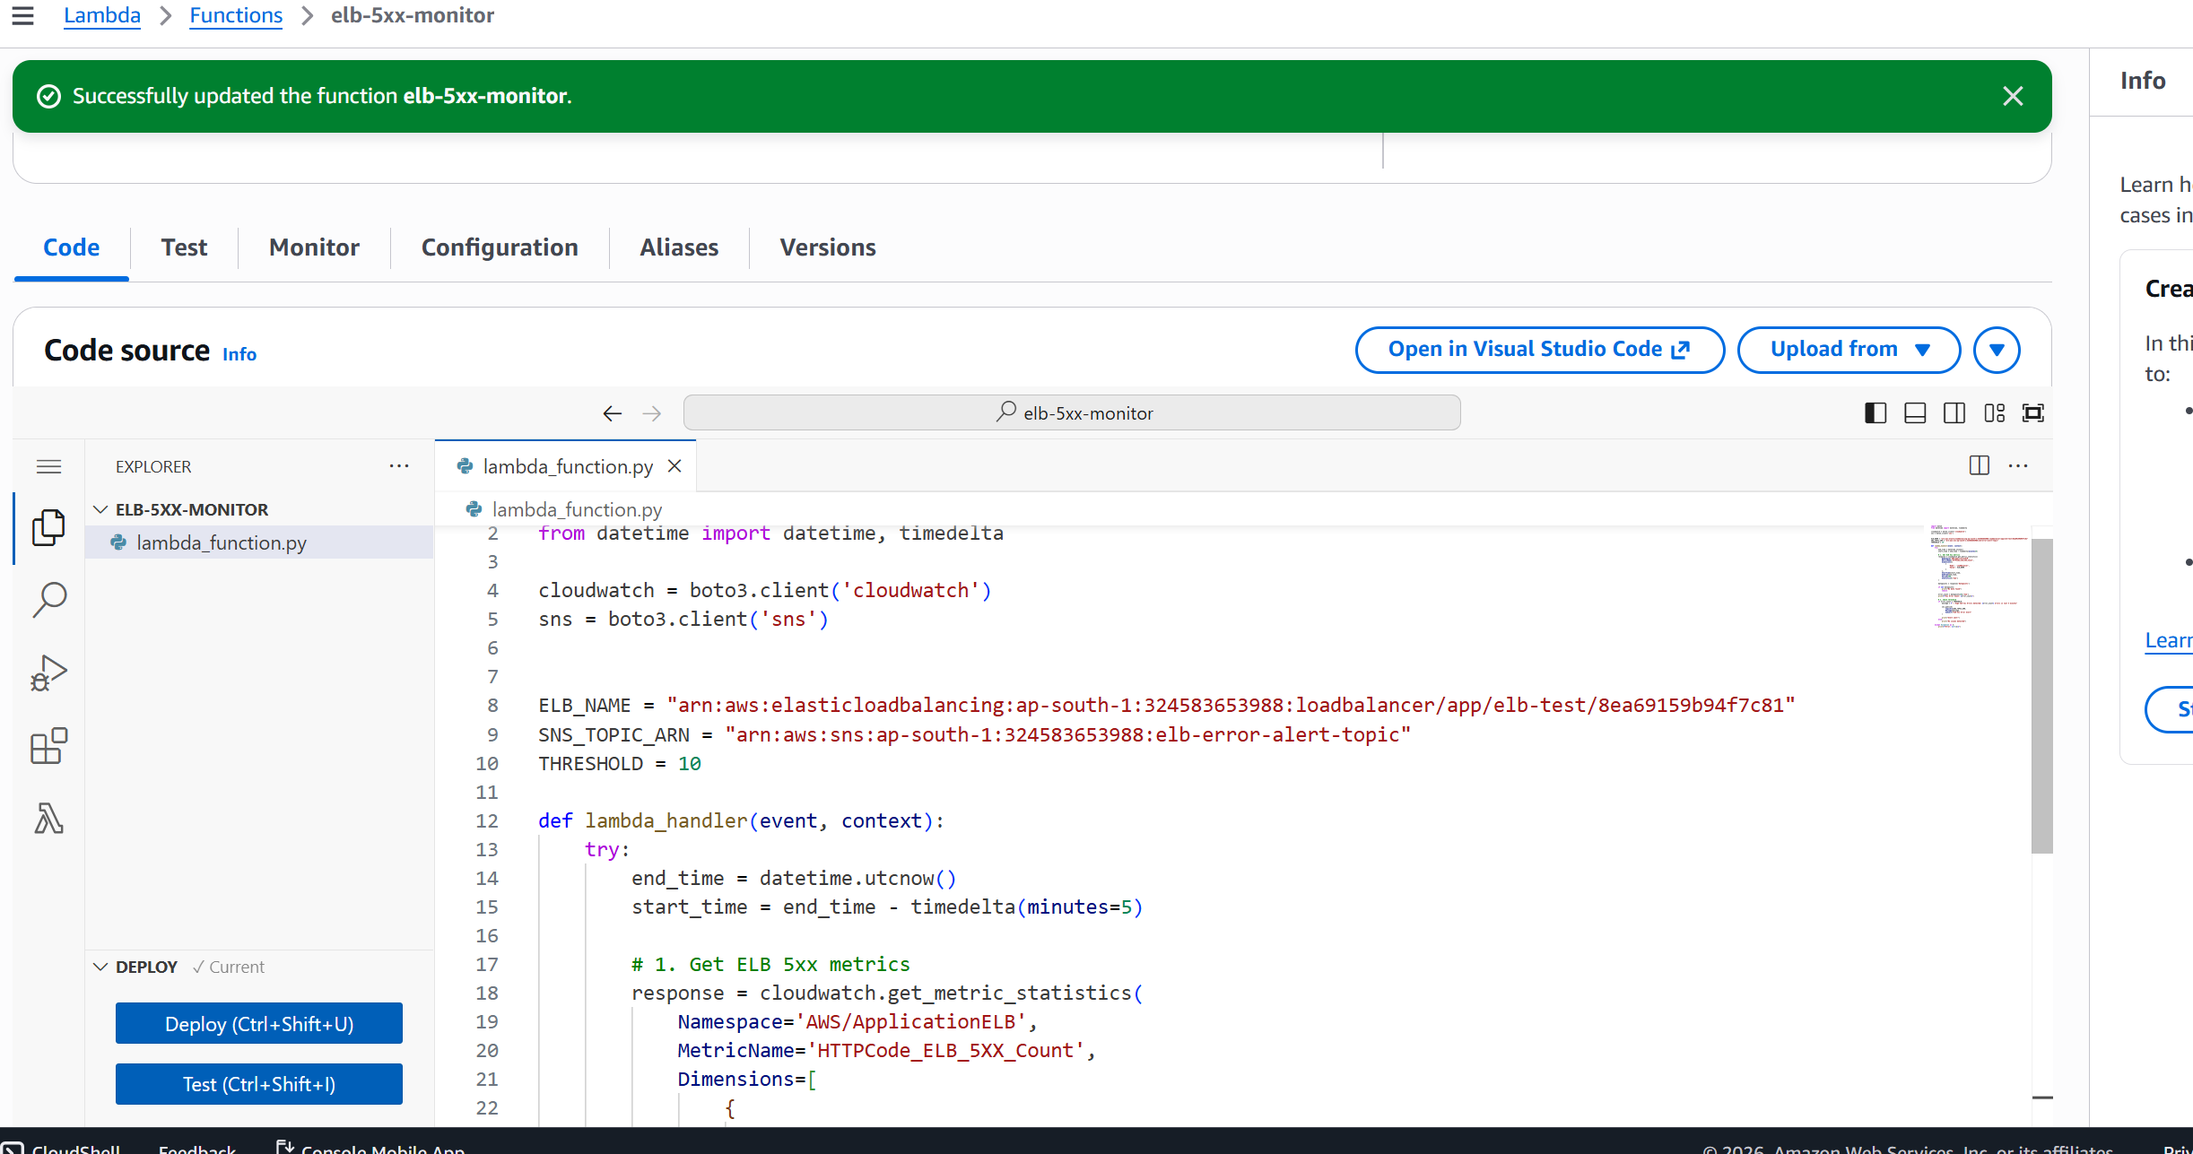
Configured schedule event bridge for every 5 mins
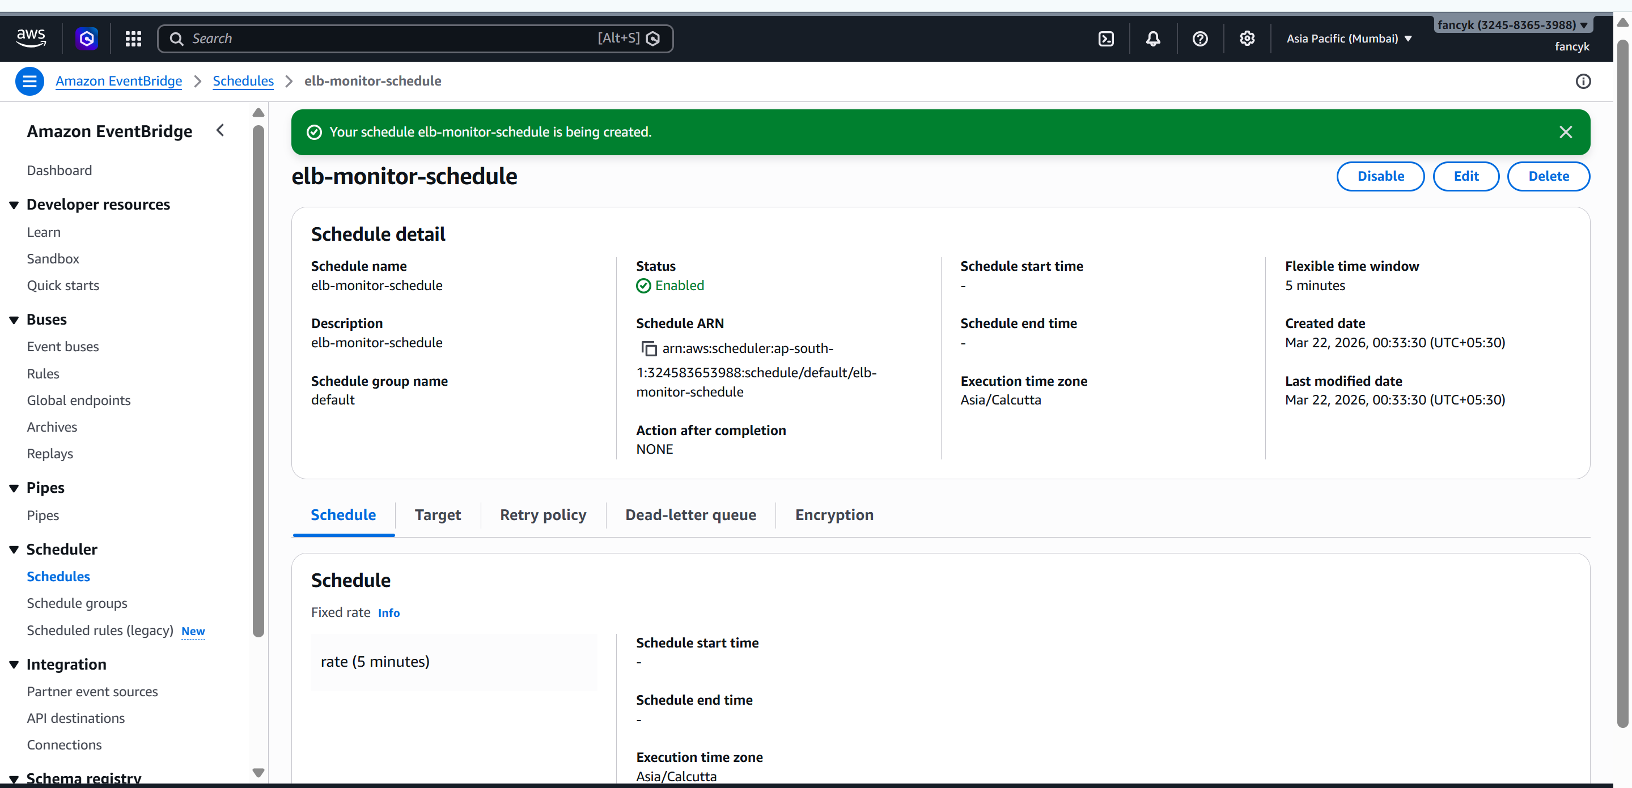
Expected output
